* Setup the Firestore Database
  + Click on Go to Console and Create a New Project with the name Insurance Company (Rest of the Options are left on default)

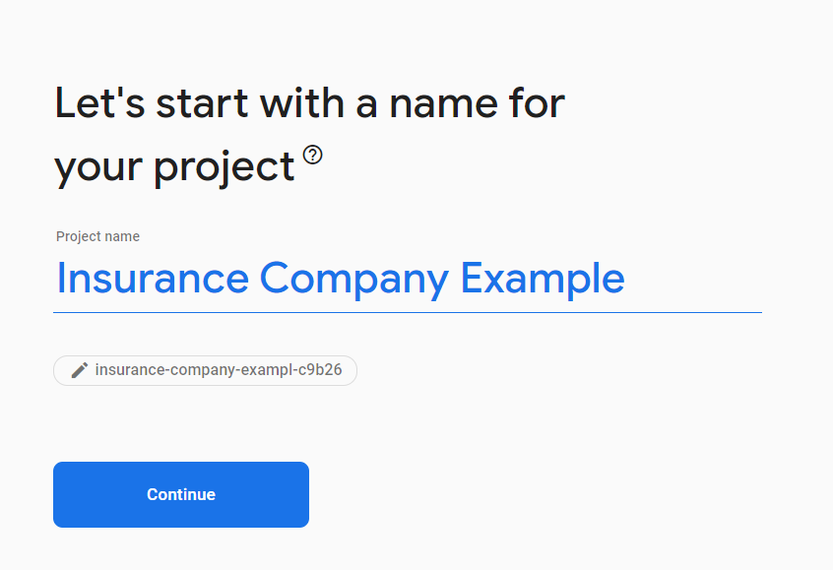

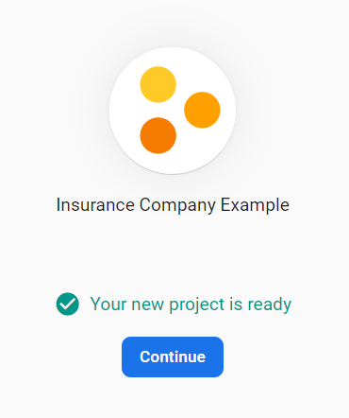

* + Click on Firestore Database and create a new Database with the following options and rules

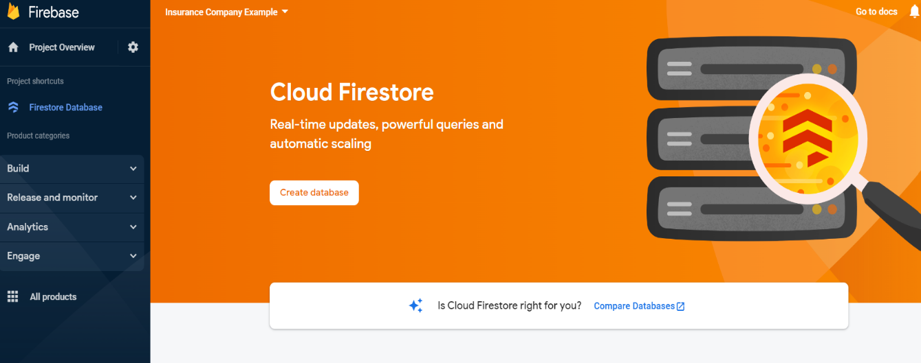

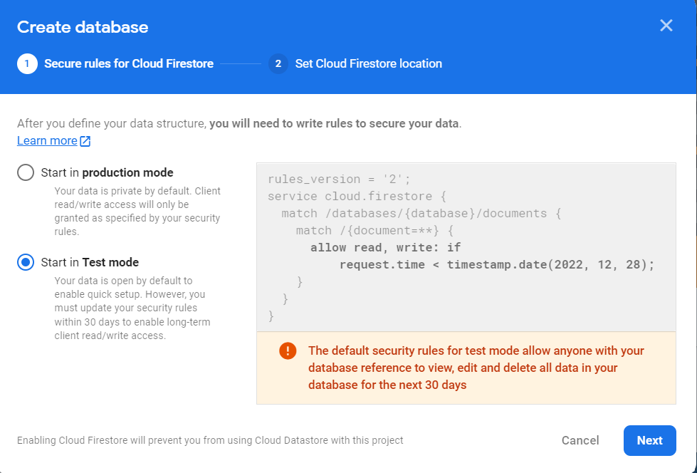

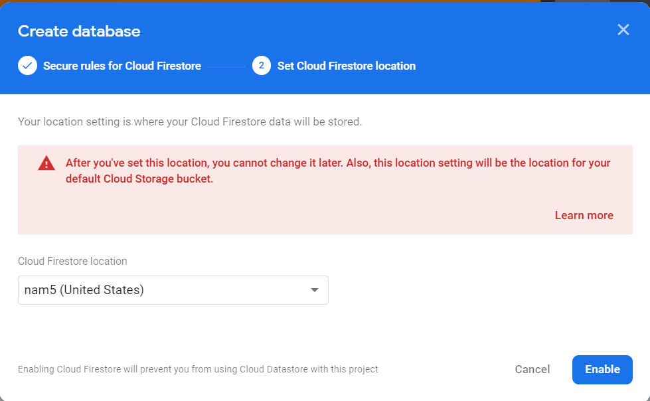

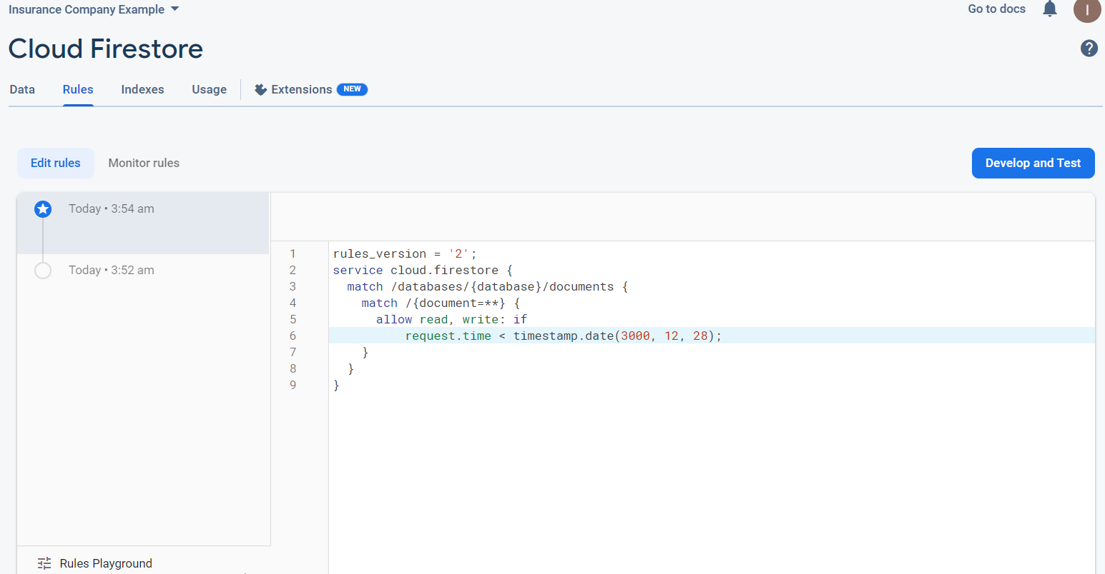

* + Click on Project Settings to Copy the Firebase Config and paste it into a file called clientDbMgr.js in the clientdataforrpa folder in VsCode

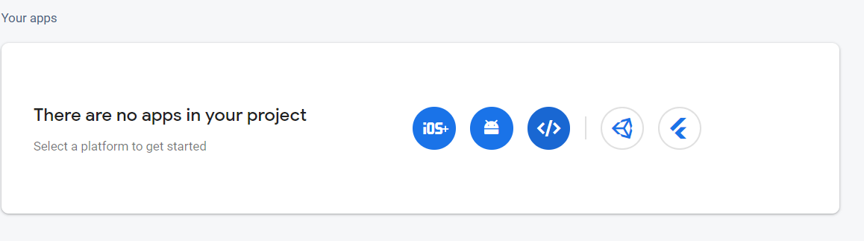

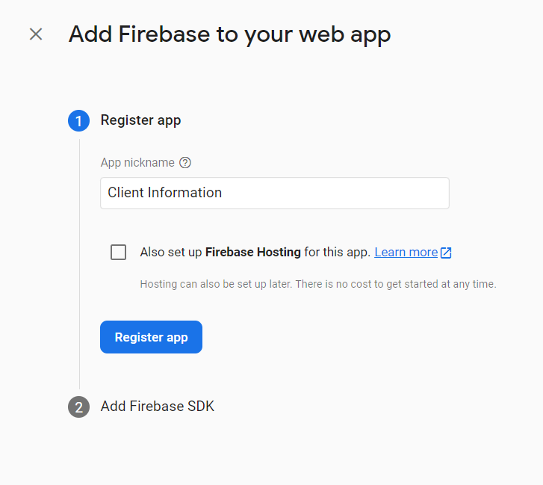

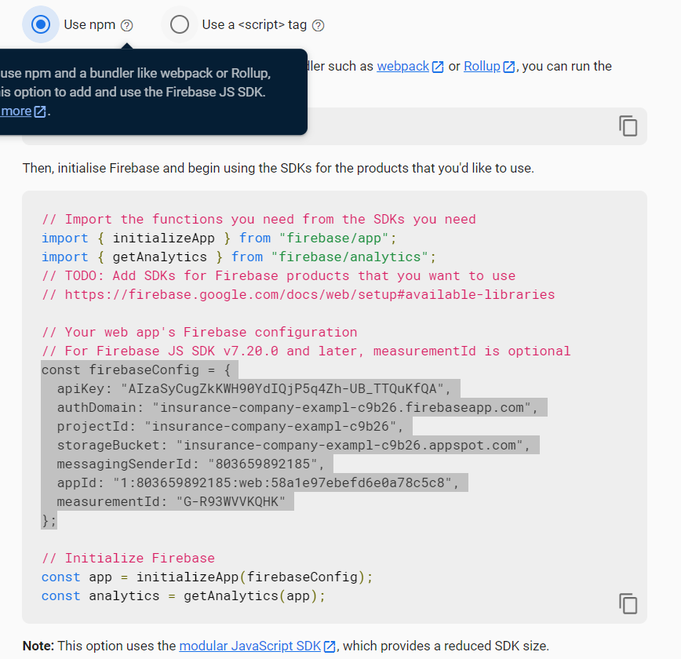

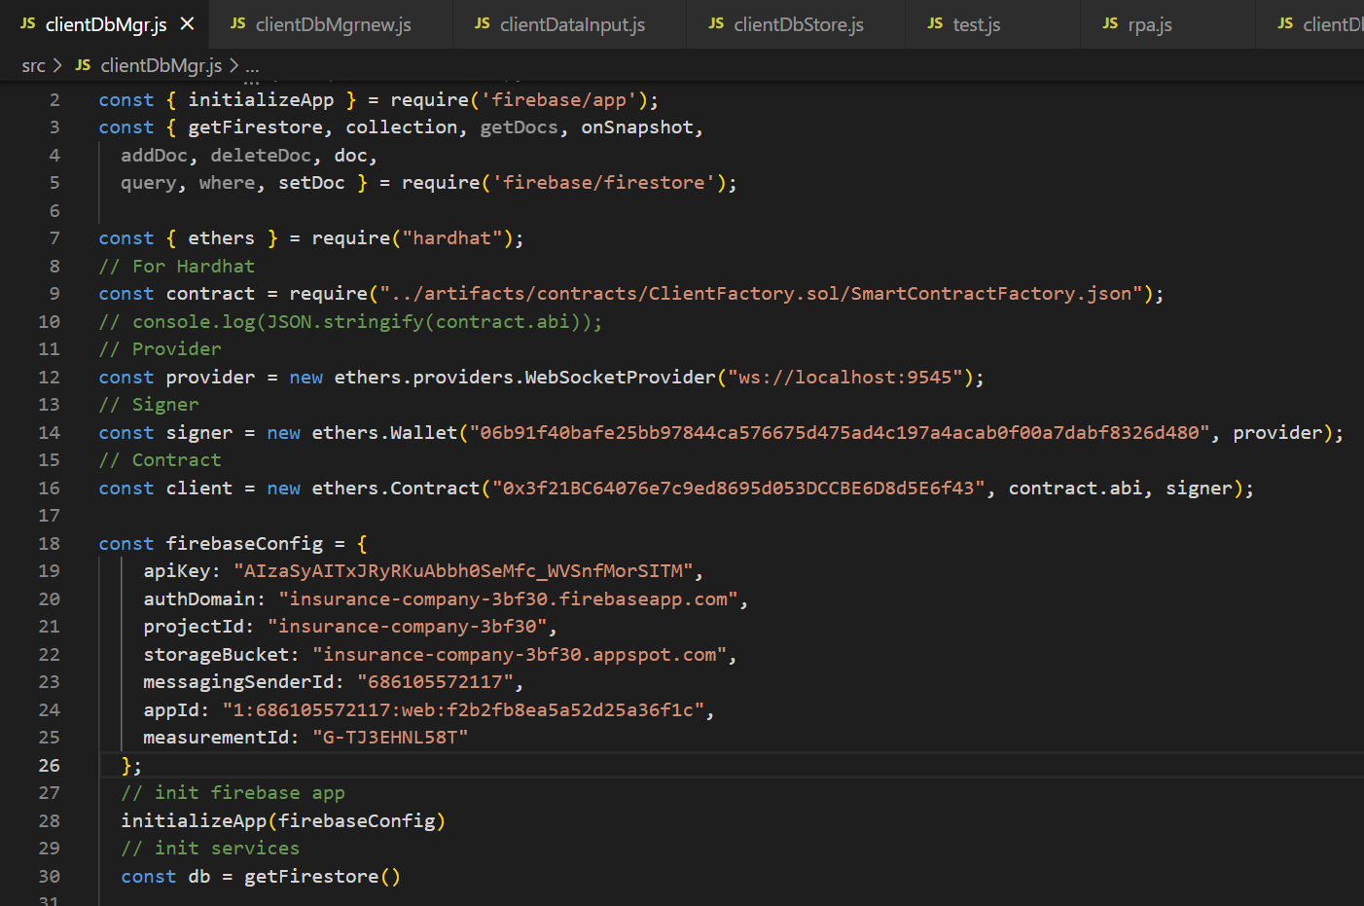

Once pasted, you should be successfully connected to your existing Firestore database! You will also be able to successfully integrate with your hardhat codes on node.js through the usage of const = require(“”) statements instead of import statements with Firestore (mjs => cjs)